My project uses a CLI based interface for users to define object schemas based on domain java classes that can determine field subsets of the original class. From these validated object schemas, objects can be instantiated and related to other user-defined objects dynamically at runtime. The use of the Reflections Library is what allows the program to read in the base classes at runtime and obtain Class<?> references which enable the rest of the program to use the java.lang.reflect API. The program is useful as a way to test object relationships and create variations through runtime usage rather than code. The following program execution shows how some of the main functions of the program work and its capabilities.
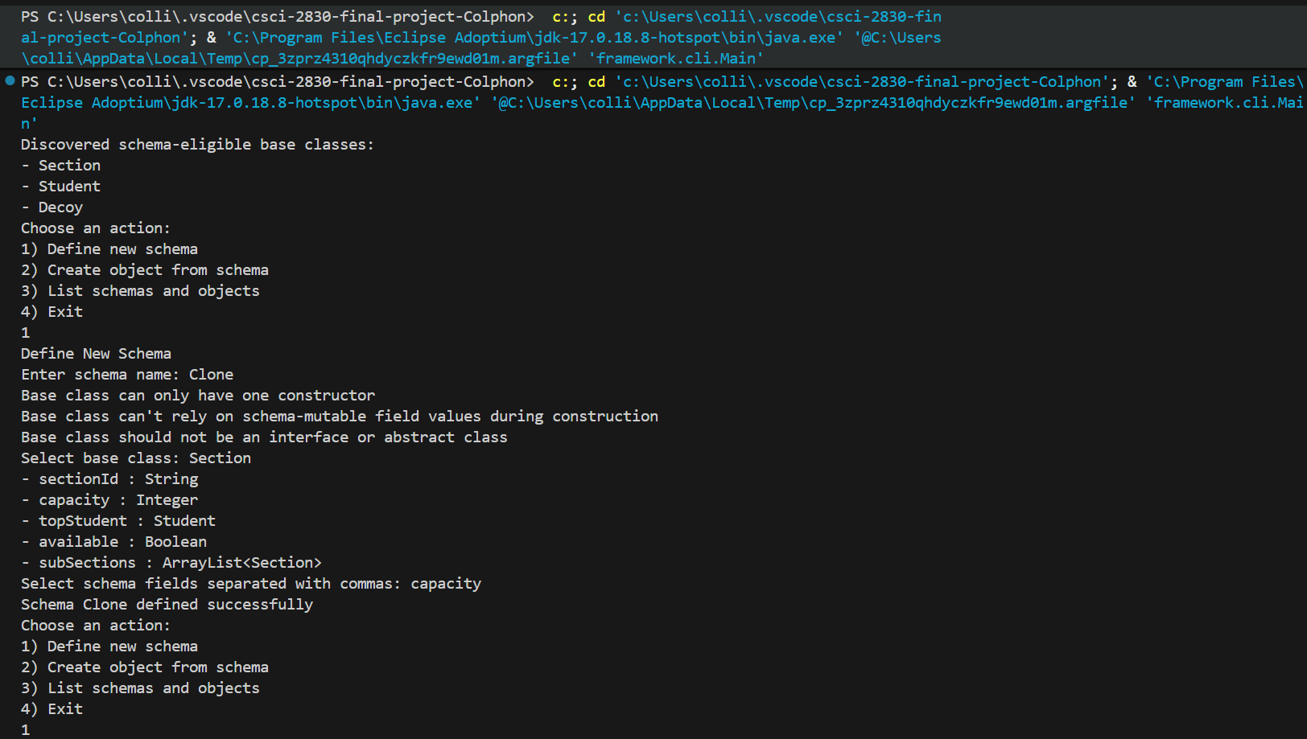
To start, the program displays the files found in the domain via the Reflections library, and presents you with options 1-4. First, I define a schema named Clone and get a few disclaimers. The first and last disclaimer are about things that the program didn’t implement (not needed for baseline program). The second disclaimer is there because later when objects are created, they use default values for fields during object construction and then modify the field values afterwards. If any important logic happens in the constructor that is based on schema-mutable fields, then it means that the object is constructed using default values instead of user-inputted ones, creating unintended behavior. Additionally, any logic reliant on fields during construction is basically stating that those fields are essential. Any omission of those fields would be antithetical to the restrictions of the base class.
Moving on, I choose the domain file Section as my base class, and the program displays the fields of the class. I then choose Integer capacity as the only field for my schema Clone.
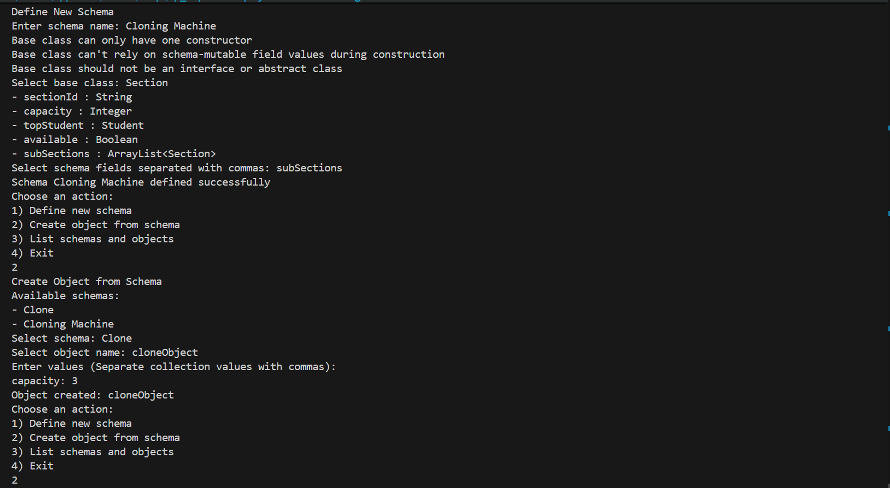
Next, I create a new schema named Cloning Machine with base class Section. I choose ArrayList<Section> subSections as my only field for this schema. I then go to option 2 and create an object from schema Clone named cloneObject, and input 3 into its capacity field.
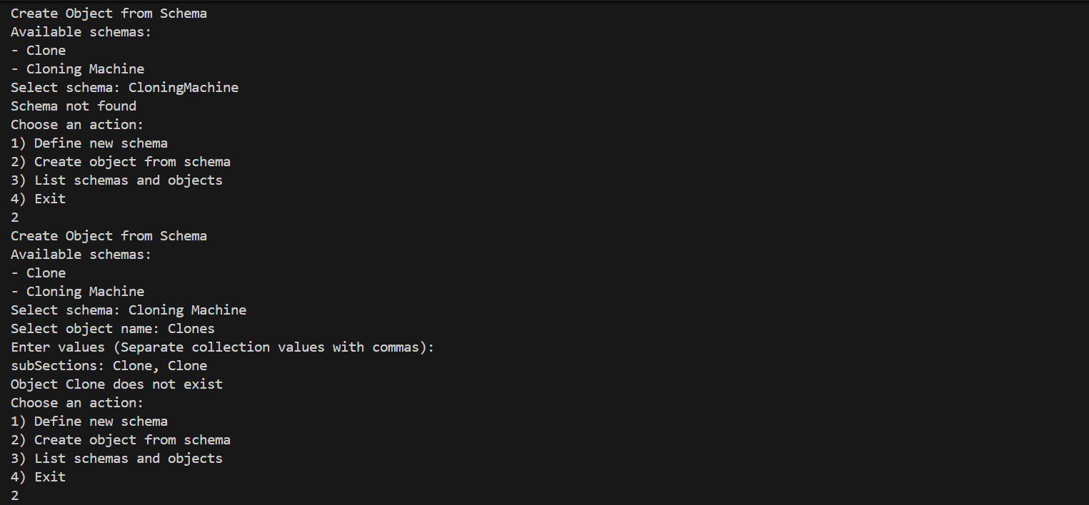
I then try to create an object from Cloning Machine but miss a space and get rejected (Cloning Machine != CloningMachine). I retry and create the object Clones, and fill its subSections field with two Clone—schemas—and get rejected.
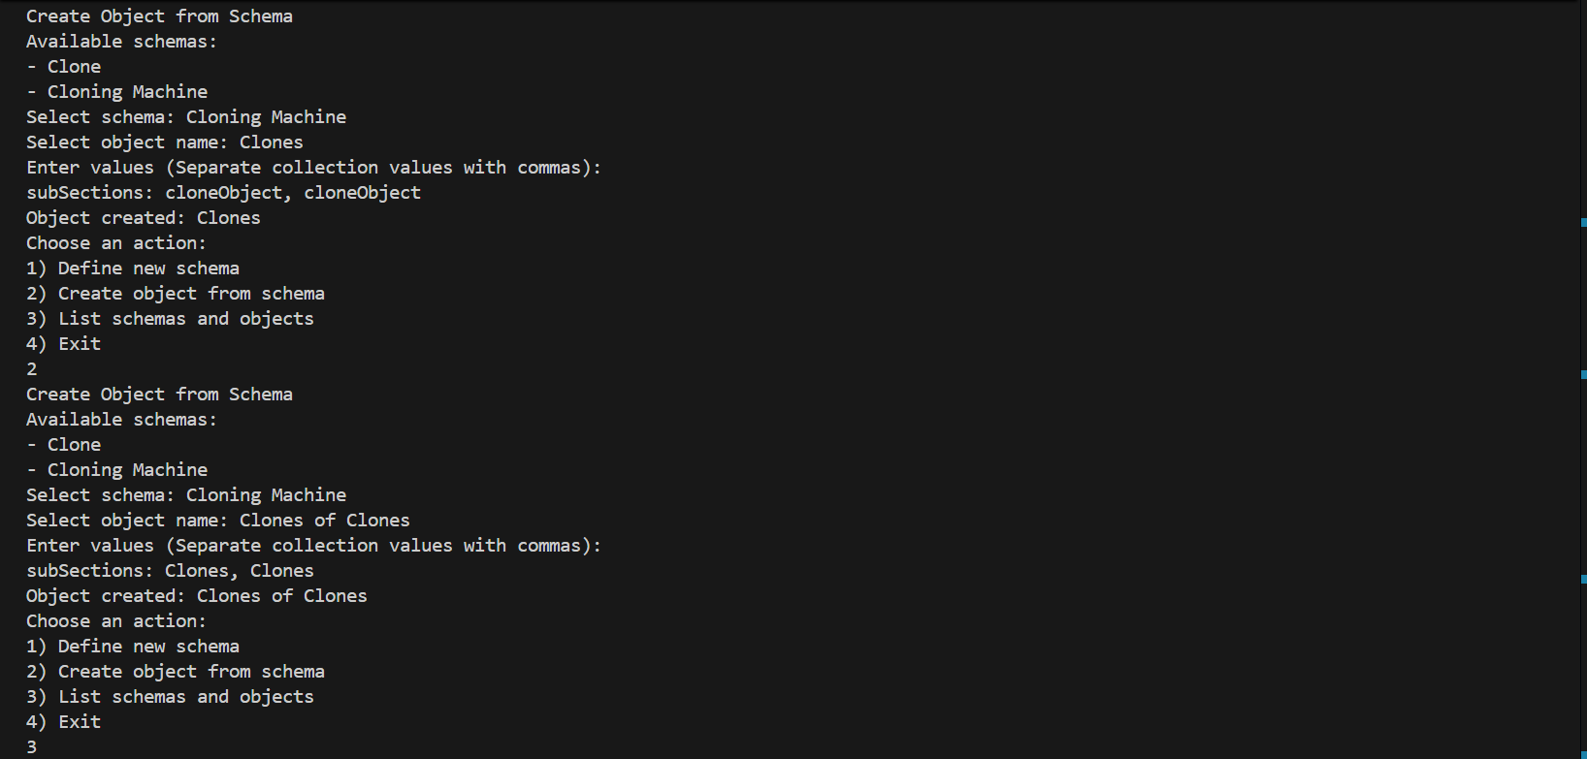
I retry and properly fill subSections with two instances of my Clone object cloneObject. Then, I create another object from Cloning Machine called Clones of Clones, and fill field subSections with two instances of object Clones. I then choose option 3.
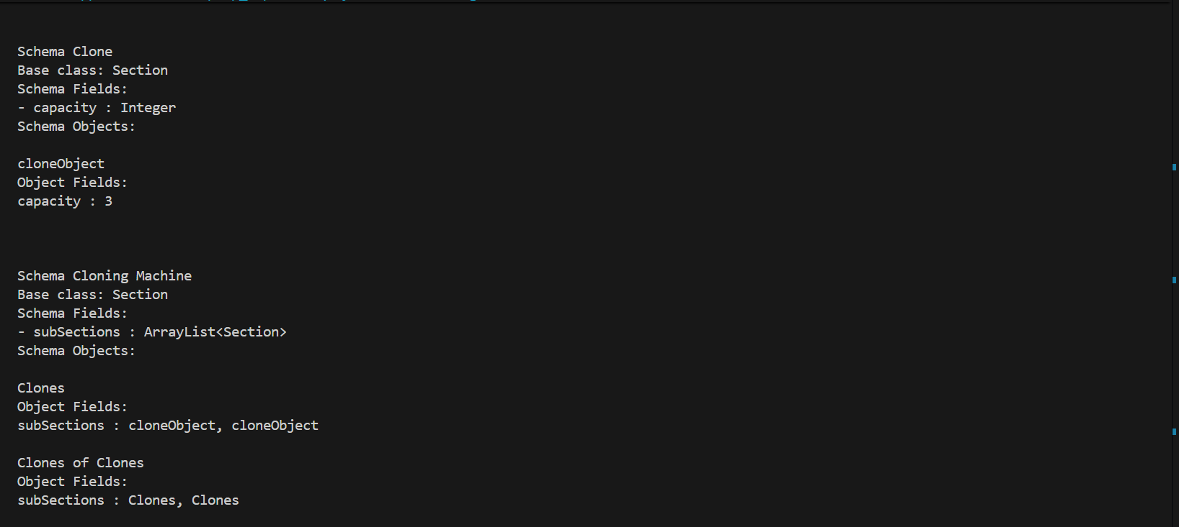
The result is a display showing all the object relations established through the program usage. Scema Clone has a cloneObject with a field value of 3 that is contained twice in object Clones from schema Cloning Machine in its field subSections. Clones of Clones from schema Cloning Machine then contains two instances of Clones in its subSections field. This allows for powerful recursive object relations that allow for complex object linking without writing new code.
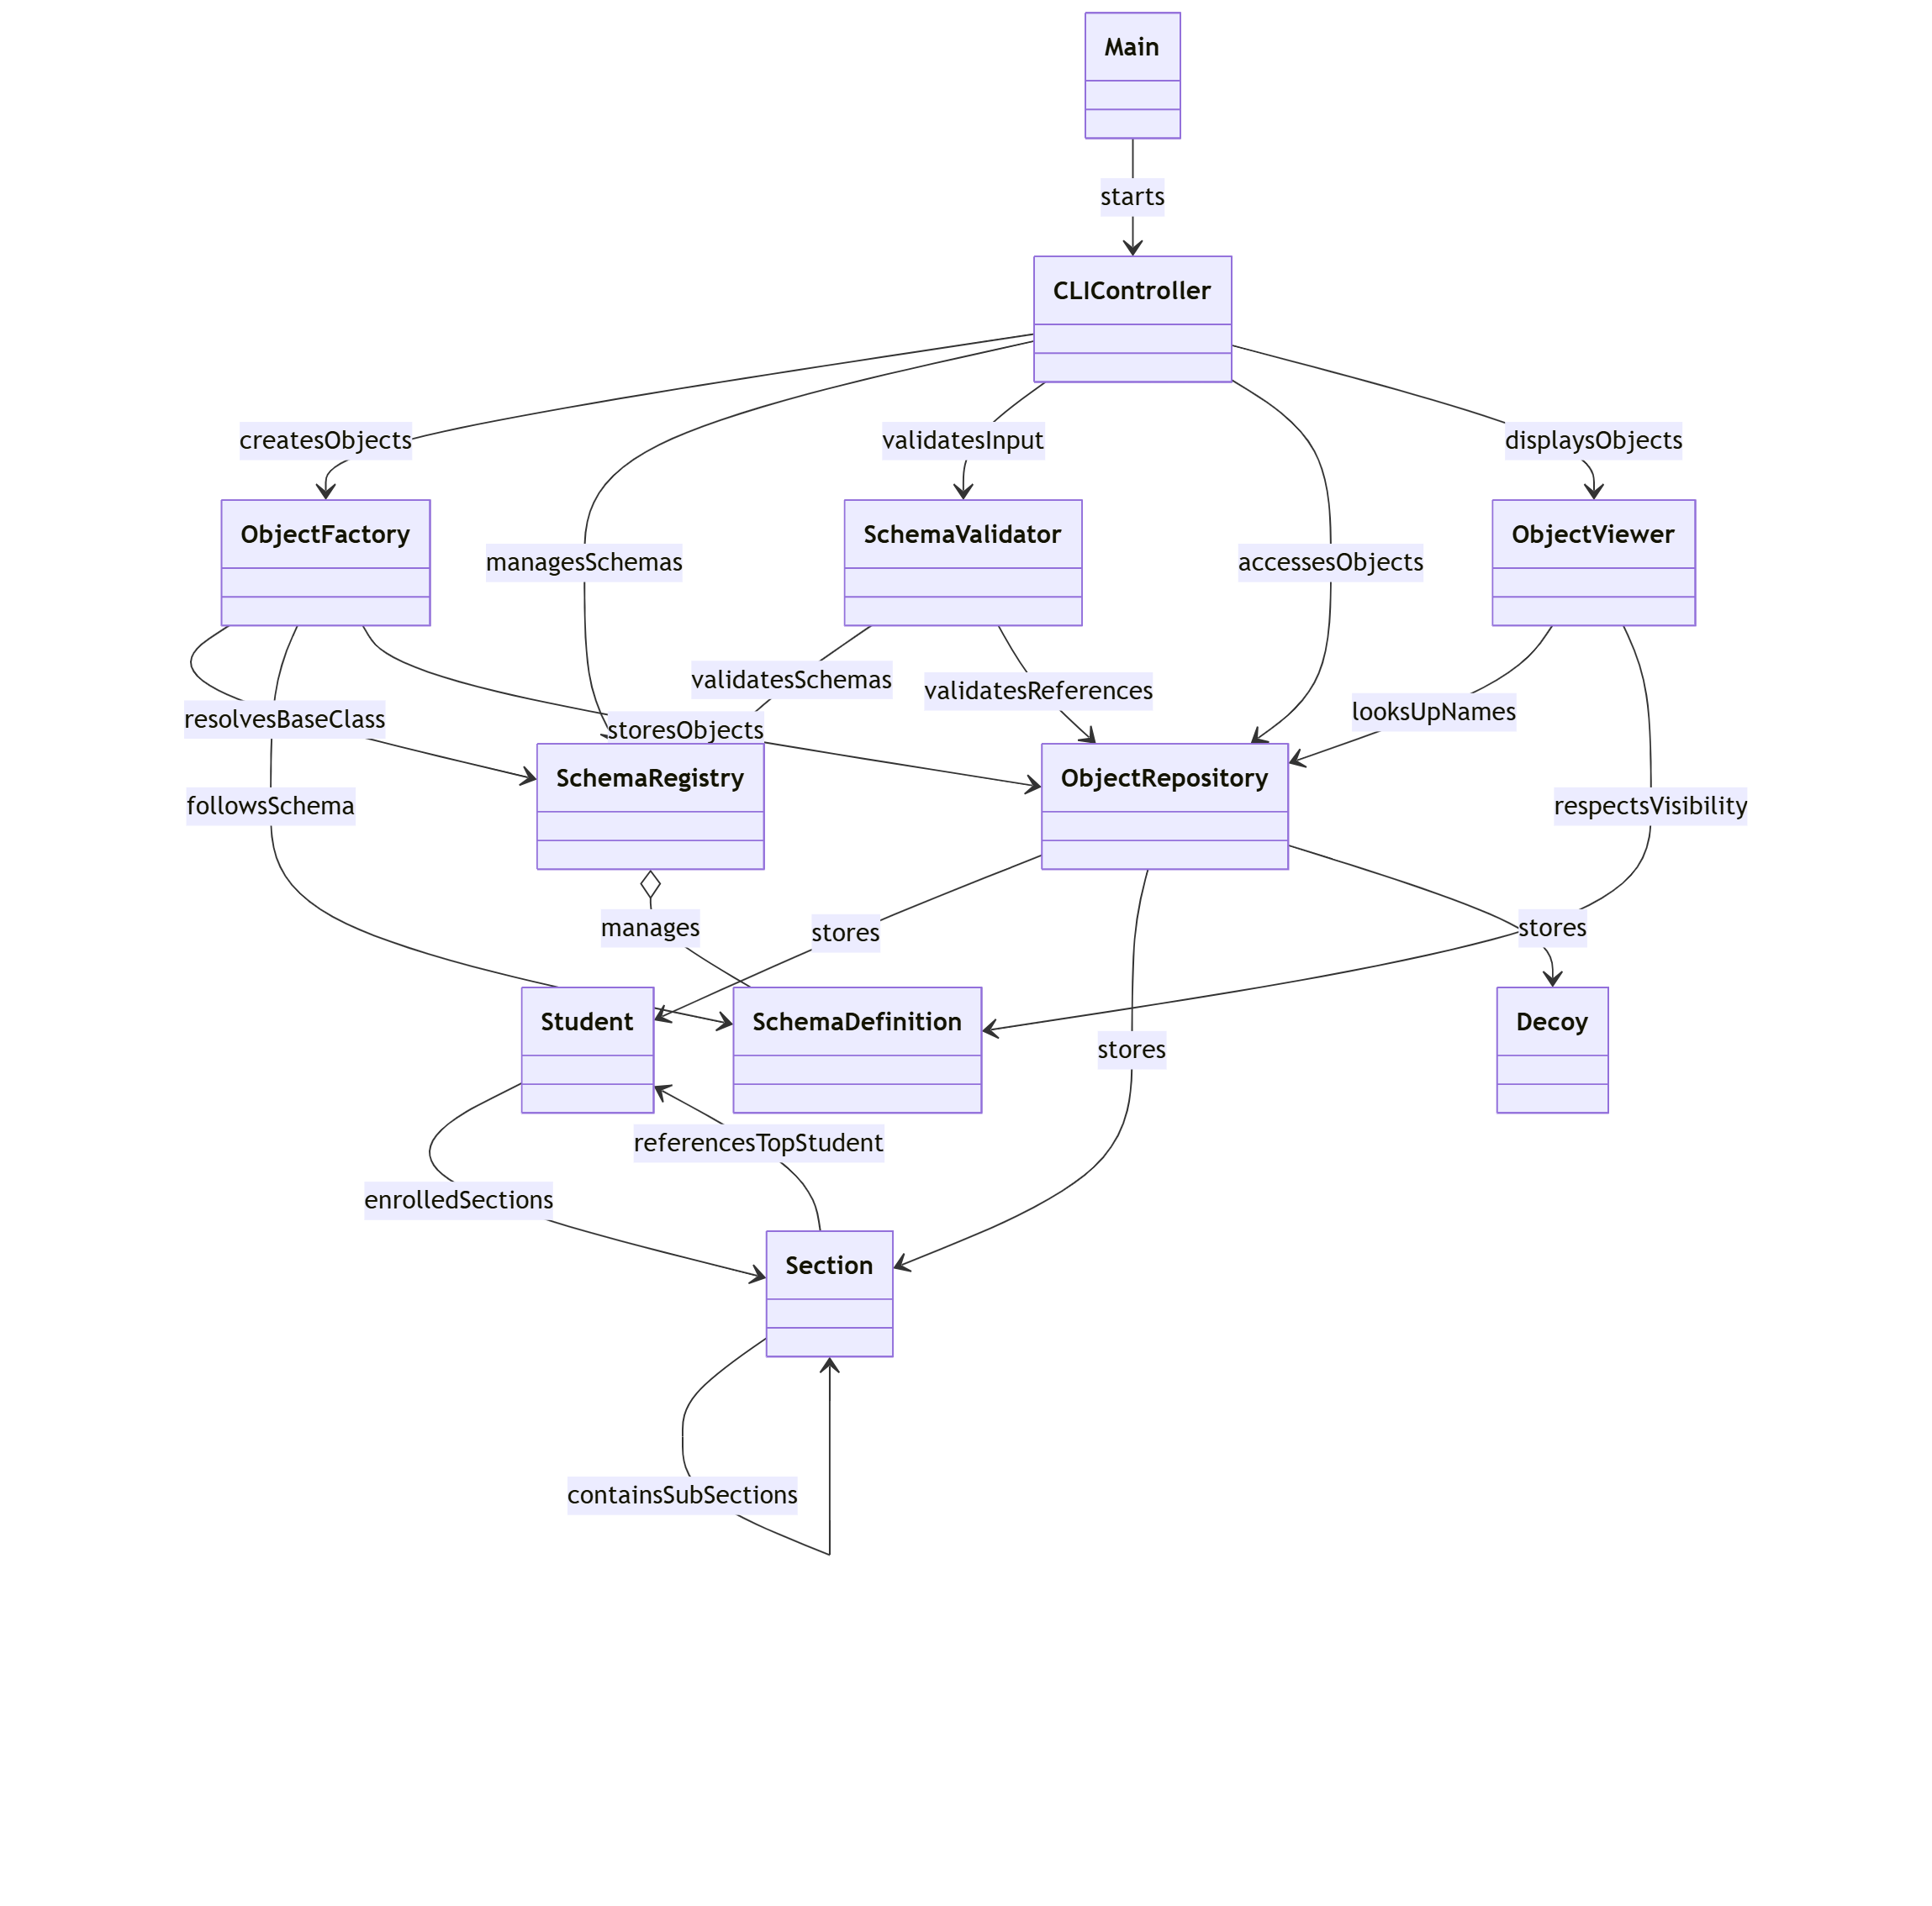
As previously stated, I used the Reflections library to discover and get the Class<?> references from package domain which java reflection then used to get all the information needed for display, validation, etc. The annotation @SchemaEligible was also used to differentiate between classes that should and shouldn’t be scanned using Reflections method getTypesAnnotatedWith(SchemaEligible.class). The main challenge that came from Reflections is that it clashed with the pom file and the module configuration made from it and my module.info. This resulted in the language server preserving the module startup state even upon workspace reloads, preventing classpath scanning. To make the Reflections library recognized by my language server, I had to go into my files and delete the cached JDK and module configuration files so that Maven could rebuild everything from scratch. As for java.lang.reflect, here is a comma separated list of every method.
java.lang.reflect: getDeclaredFields(), getDeclaredField(String name), getDeclaredConstructors(), isInterface(), getModifiers(), getSimpleName()
java.lang.reflect.field: getName(), getType(), getGenericType(), setAccessible(true), set(Object instance, Object value), get(Object instance)
java.lang.reflect.Constructor<?>: getParameters(), setAccessible(true), newInstance(Object... args),
java.lang.reflect.Parameter: getType(), getParameterizedType()
java.lang.reflect.ParameterizedType: getRawType(), getActualTypeArguments(),
These methods helped me inspect class structure, enforce schema constraints, and construct objects with defaults. They also helped with altering and displaying schema-approved fields, validating runtime object references, and enforcing generic type correctness. The biggest challenge was definitely figuring out how to use the methods to actually get what I want. Do you want to match the generic type? The raw type? The class object? How do you get that from field? What do you do with what you get? Do you have to convert what you obtain from that to something else before you can use it? For instance, to properly display the type of a collection of object references this is how the code looks:
ParameterizedType pType = (ParameterizedType) feld.getGenericType();
Class<?> rawType = (Class<?>) pType.getRawType();
String containerName = rawType.getSimpleName()
Type containerArg = pType.getActualTypeArguments()[0];
Class<?> argClass = (Class<?>) containerArg;
String ArgName = argClass.getSimpleName();
output += containerName + "<" + ArgName + ">";
First (after I know the field is a collection) I have to get specifically the generic type, add (ParameterizedType) so the compiler treats it as such, then get the (Class<?>) of the raw type of my ParameterizedType. Only then can I get the first half of the type name as a String. Then I have to get the type of the list elements by inspecting the first element, then convert that to a Class<?>, and finally use getSimpleName() to get the proper name. Finally, I combine the “ArrayList/Collection type” found in containerName and combine that with “Section/Student/etc” found in ArgName to finally make the type display proper.

Github Repo: unocsci2830/csci-2830-final-project-Colphon: unocsci2830sp26-csci-2830-final-project-testautograde created by GitHub Classroom

